IN THE COMMISSIONERS COURT
OF
HOWARD COUNTY, TEXAS
ORDER CONFORMING ELECTION PRECINCTS
TO REVISED CITY OF BIG SPRING CITY COUNCIL PRECINCTS

BE IT REMEMBERED, that on the 11th day of April, 2022, the Commissioners Court of Howard County, Texas, adopted revised boundaries for its Election precincts, pursuant to Article V, Section 18 of the Texas Constitution, §81.021 of the Texas Local Government Code, and Chapter 42 of the Texas Election Code.

Pursuant to the provisions of Chapter 42, Texas Election Code, the Commissioners Court hereby approves the realignment of County Election Precincts to conform to the newly revised and adopted boundaries of the city of Big Spring City Council precincts:

In the map depictions of election precincts below, the blue lines are former boundaries, red lines are new city precinct boundaries. Former election precinct territory may appear in red type, new election precinct numbers in a black box with white letters.

- Election Precinct 34 is modified to accommodate the Big Spring precinct by the creation of a new election precinct, to be identified as 31A, to move territory formerly in Election Precinct 34 into new Election Precinct 31A, with the area bounded on the north by the centerline of Martin Luther King Blvd., beginning at the intersection of Martin Luther King Blvd, with the centerline of FM 700; thence south and east along FM 700 to the boundary of the Scenic Mountain Medical Center property; thence northerly along the western boundary of the Scenic Mountain Medical Center property to a point of intersection with the centerline of Martin Luther King Blvd; thence west with the centerline of Martin Luther King Blvd to the point of beginning, as depicted on the attached map.

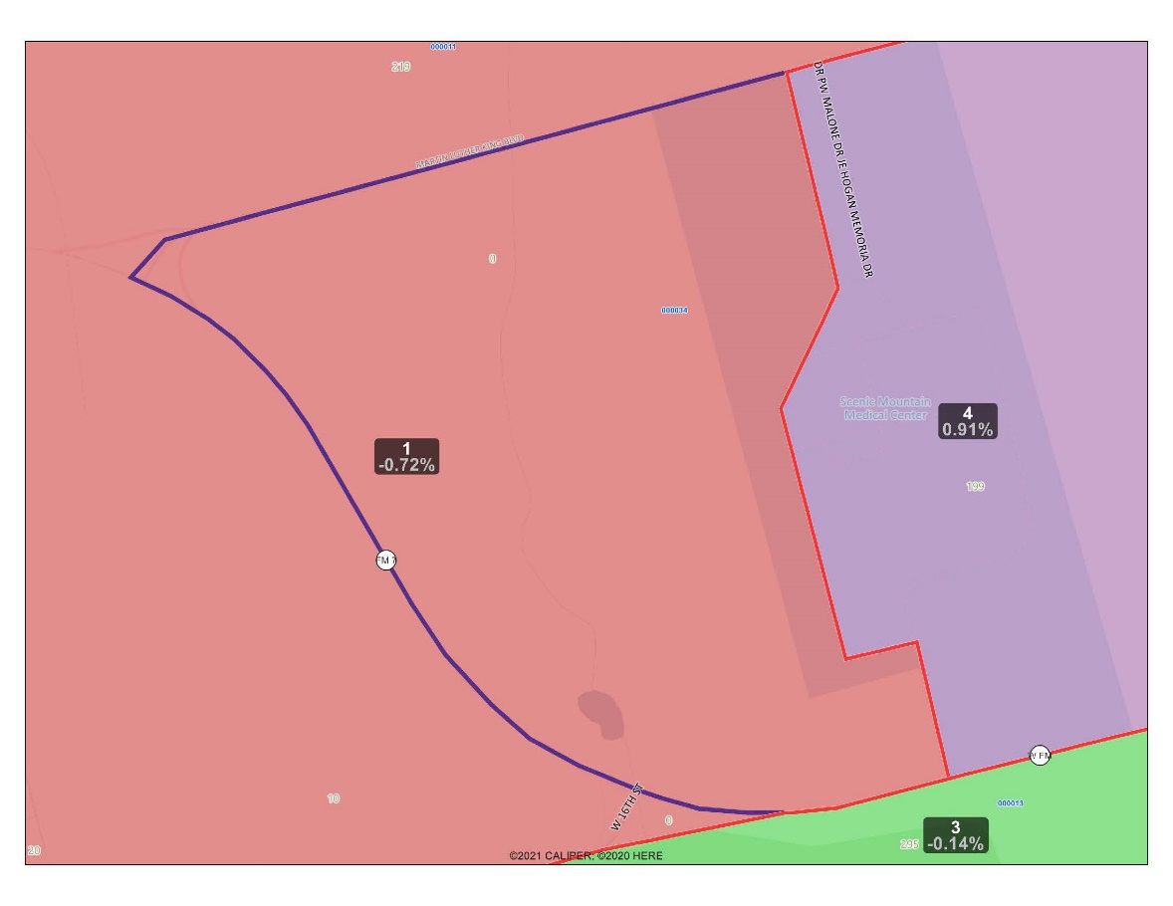
34
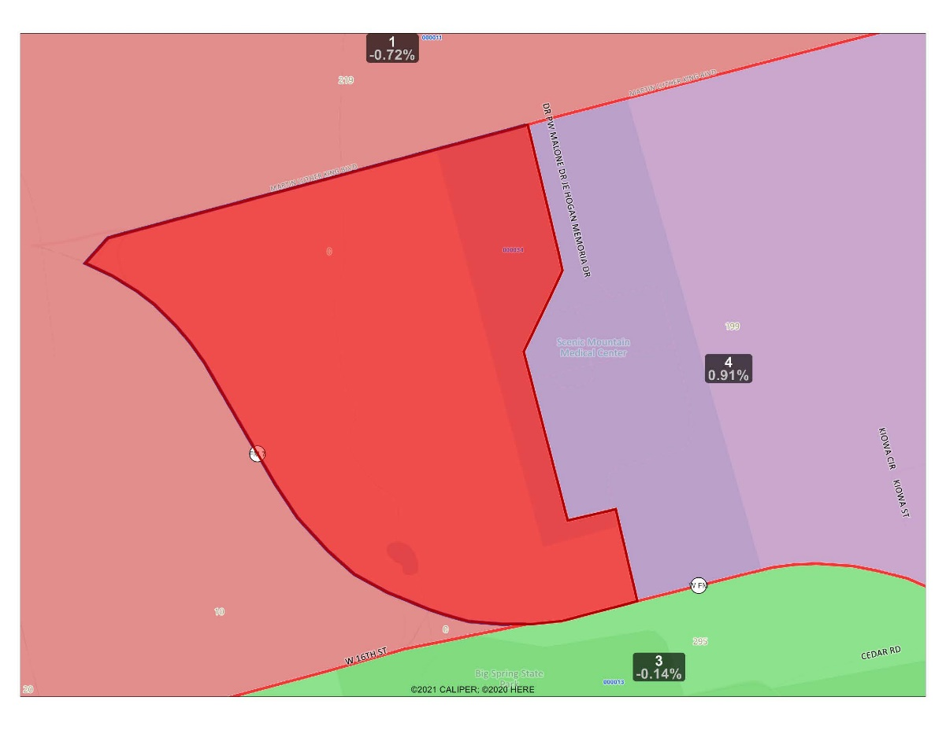
31A

- Election Precinct 42 is modified to accommodate the Big Spring precinct by the creation of a new election precinct, to be identified as 41, to move territory formerly in Election Precinct 42 into new Election Precinct 41, with the area bounded on the north by the centerline of W. 7th Street, beginning at the intersection of W. 7th Street and the centerline of S. Gregg St.; thence south along S. Gregg Street three blocks to the point of intersection with the centerline of W. 10th St.; thence east one block to the point of intersection with the centerline of Scurry St.; thence north along Scurry St. to the point of intersection with the centerline of W. 7th St.; thence west along W. 7th St. to the point of beginning, as depicted on the attached map.
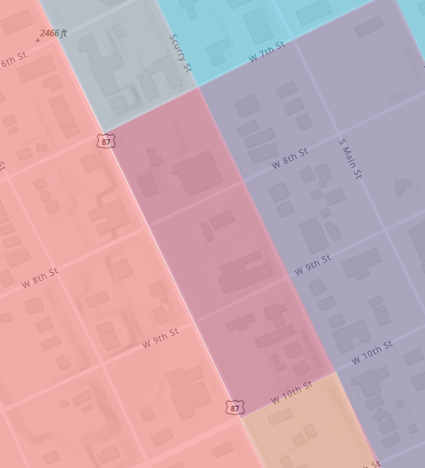
42

41

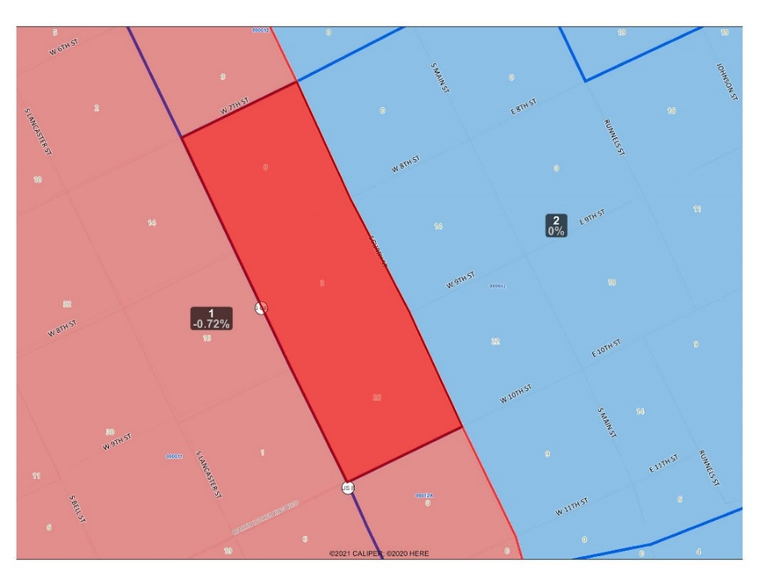

- Election Precinct 34 is modified to accommodate the Big Spring precinct by the creation of a new election precinct, to be identified as 34A, to move territory formerly in Election Precinct 34 into new Election Precinct 34A, with the area bounded on the north by the centerline of E. 16th St., beginning at the intersection of E. 16th St., with the centerline of Nolan St.; thence south along Nolan St. to a point of intersection with the centerline of E. 18th St.; thence east with the centerline of E. 18th St. to the point of intersection with the centerline of Goliad St.; thence north to the point of intersection with the centerline of E. 16th St.; thence west along E. 16th St to the point of beginning, as depicted on the attached map.
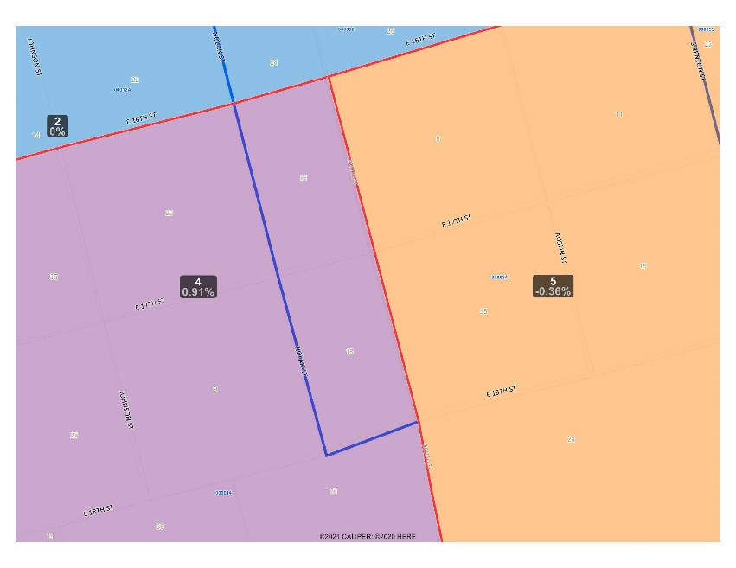
34

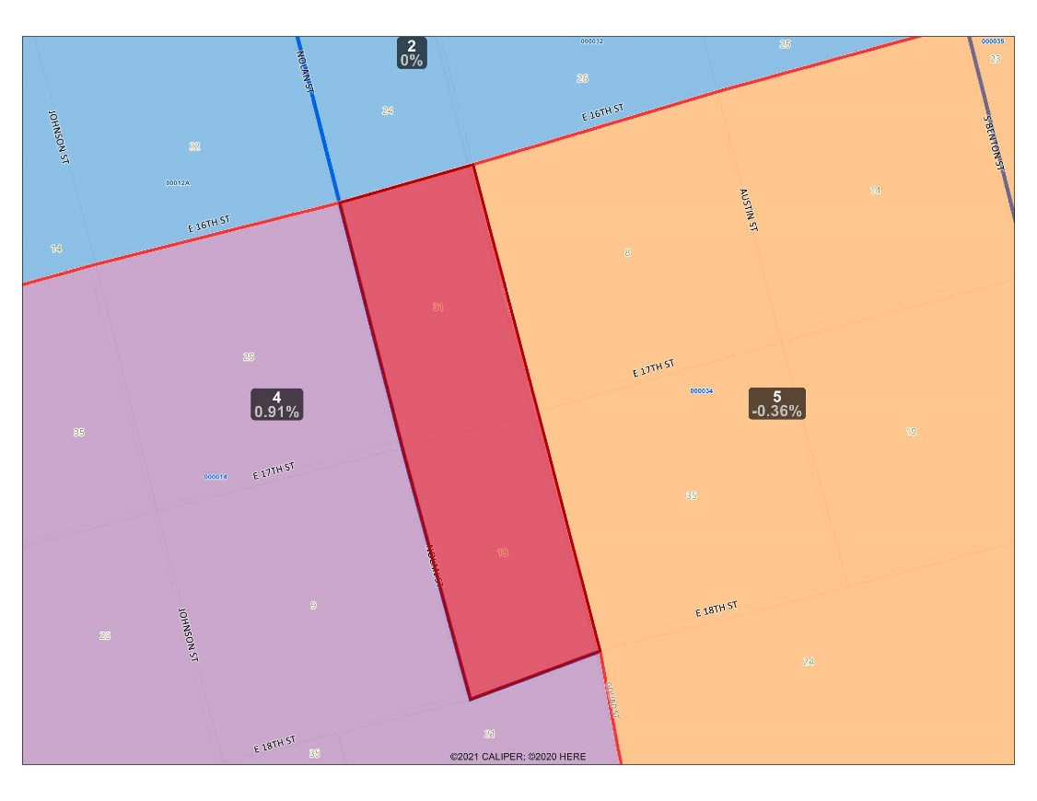

34A
- Election Precinct 34 is modified to accommodate the Big Spring precinct by the creation of a new election precinct, to be identified as 31, to move territory formerly in Election Precinct 34 into new Election Precinct 31, with the area bounded on the north by the centerline of Douglas Street, beginning at the intersection of W. 10th/MLK Blvd., with the centerline of Douglas St.; thence south along S. Lancaster.; to a point of intersection with the centerline of W. 16th.; thence east with the centerline of W 16th^{th} St. to the point of intersection with the centerline of S. Lancaster.; thence north to the point of intersection with the centerline of W. 10th/MLK Blvd..; thence west along W. 10th St to the point of beginning, as depicted on the attached map.

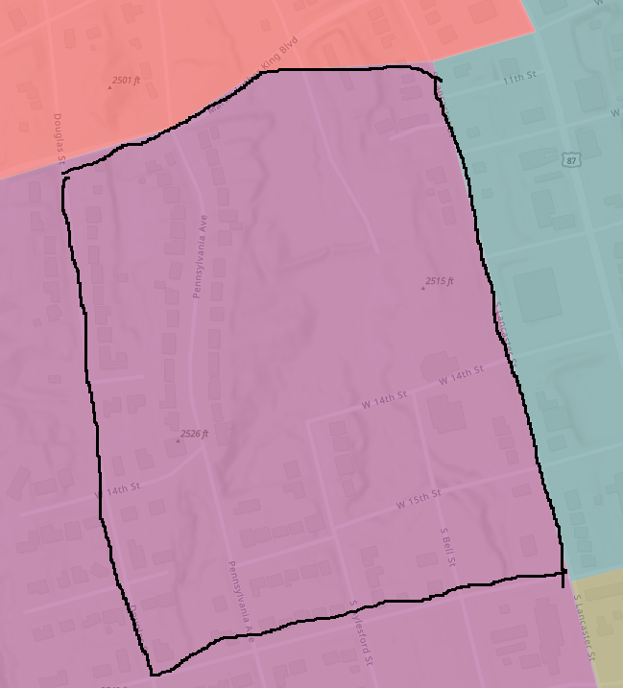
34

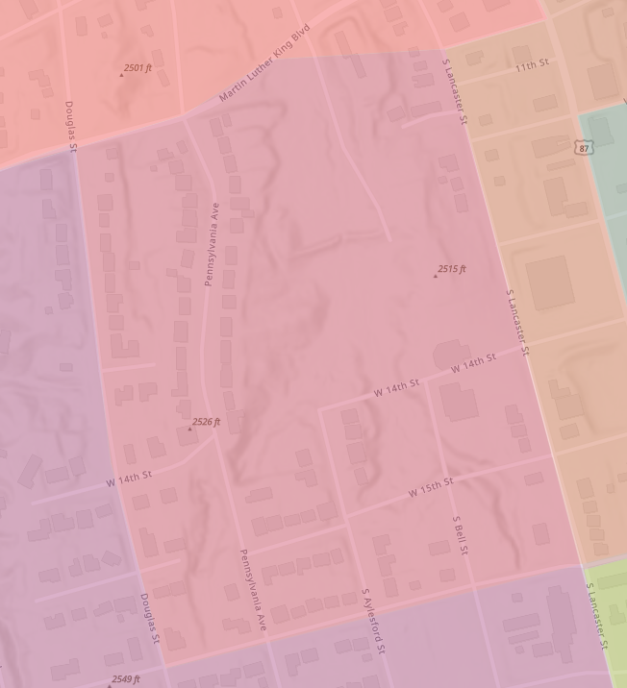
31

- To the extent that any of the foregoing revised election precincts contain territory inside a city with unincorporated territory outside of the affected city, the Commissioners Court, pursuant to §42.007 (1) and (2), finds that either of the two areas (within and without the incorporated city) cannon constitute a separate election precinct of suitable size or shape that contains the permissible number of voters, or cannot be combined with other territory on the same side of the city boundary to form an election precinct of a suitable size or shape that contains the permissible number of voters without causing another election precinct to fail to meet those requirements. The Commissioners Court delegates’ sufficient discretion to the Office of Elections Administration to make such boundary adjustment to said election precincts to facilitate the effective administration of elections, and to pose the least inconvenience to the voters of the affected election precincts.

The above and foregoing changes to Election Precincts shall take effect April 11, 2022, and will remain in effect until changes by further Order of this Commissioners Court.

Signed this 11th day of April, 2022

_______________________________
County Judge

____________________________________ ________________________________
Commissioner, Precinct 1 Commissioner, Precinct 2

____________________________________ ________________________________
Commissioner, Precinct 3 Commissioner, Precinct 4

Attest:

____________________________________
County Clerk

